
Company
Logotype

Cone Beam Computed Tomography- Report



Porur Dental X-rays & CBCT

Patient Name : Miss. Maya Maragatham | Date of Report : 13.04.2025
Age/ Gender : 15 years/ Female | Region of Interest : CBCT Full Skull
Referring doctor: Dr. M. Balamurali Sai | Indication : Impacted tooth 13 and its orthodontic retrieval.
Clinical Notes: Nil
PATIENT INFORMATION

CBCT Full Skull provided
CBCT – IMAGE DETAILS

RADIOGRAPHIC INTERPRETATION

- Deciduous teeth present in the maxillary arch: 53.
- The tooth 13 appears to be within the alveolar bone, distally tipped with its crown in contact with the radicular portion of 12, 53 and root of 13 in contact with the medial wall of right maxillary sinus and floor of nasal cavity.
- The tooth 13 is positioned such that it involves the labial cortical bone.
- The floor of the right maxillary sinus is present with hyperdense mucosal thickening.
- The left maxillary sinus is present with mucosal thickening along the medial wall and floor.

RADIOGRAPHIC IMPRESSION


- Impacted tooth: 13
- Retained deciduous tooth: 53.
- Bilateral maxillary sinusitis.

IMAGES FOR REFERENCE

RECONSTRUCTED PANORAMIC VIEW

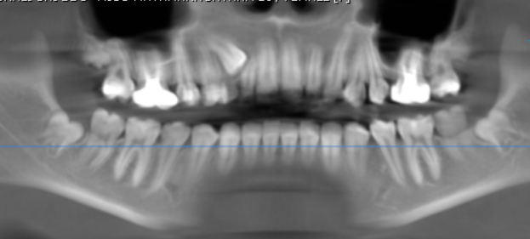
3-DIMENSIONAL VIEW

CROSS- SECTIONAL IMAGES

13 REGION | 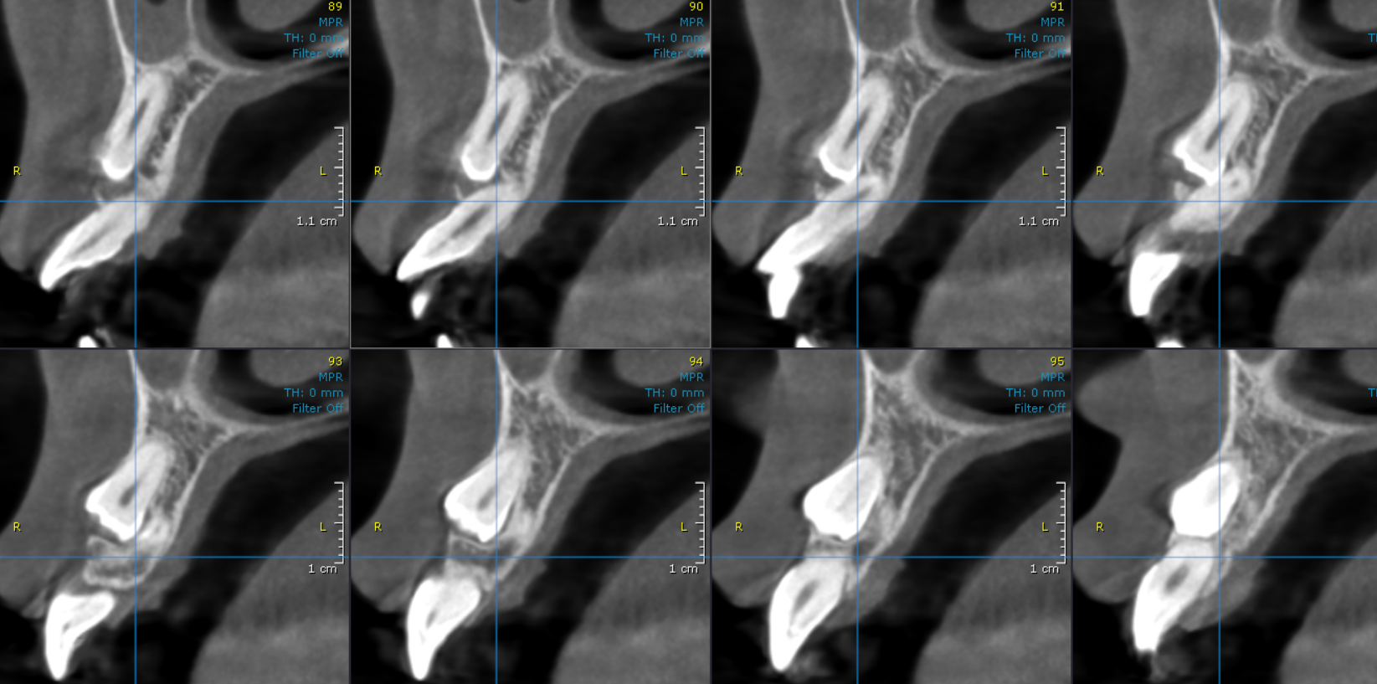
**** End of report ****

